**Ordering laboratory supplies from the OP VVV project**

Frequently ordered laboratory supplies are subject to open tenders (public procurement) and cannot be funded from the OPVVV project until the tenders are closed. Please, stick to the following temporary rules:

1. Each ordered product has to be first searched for in the list of frequently ordered items. The list is now available in Czech with short English description. The list is divided into 20 categories (see below):

|  |
| --- |
| Falcon tubes |
| Microcentrifuge tubes |
| Kits |
| Enzymes |
| Markers |
| Chemicals |
| Lab disposables |
| Microbiological and bacterial experiments |
| Oligonucleotides |
| Gases |
| PAGE supplies |
| Antibodies |
| Radiochemicals |
| Solvents |
| Septa |
| Silicagel |
| Pipette tips |
| Media for tissue and cell cultures |
| Plastic for tissue and cell cultures |
| Vials |

When ordering anything that might appear in the list, filter the list and checked the description of the items in the category or use the text search. Mind the important fact that not all items are included as particular products, but they are described only in general. Chemicals and solvents may be searched under the CAS number.

→ if the item is included, order it from another grant.

→ if the item is not included, order it from OP VVV project.

**Example:**

Ordering semi micro spectrophotometric PMMA cuvettes (for UV), for group Hocek. I guess they may be classified as “lab disposables”. I filter the excel list as in picture below and see the cuvettes are not included.

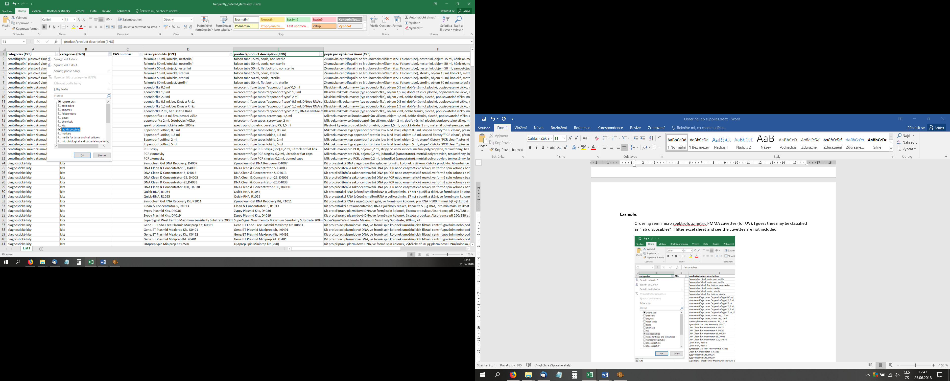

I dismiss the filter and search for “cuvettes” in the *product/product description (ENG)* column:

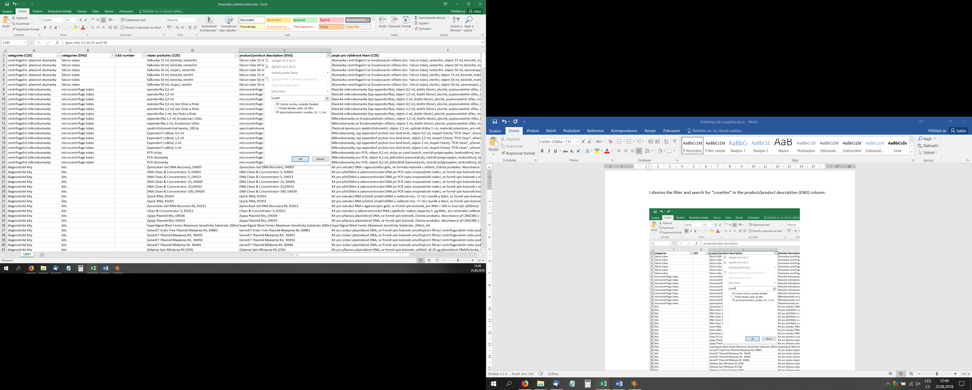

I see that the cuvettes are included (please, note that some products may be placed in other category than you would expect), but only those made from PS. I can therefore buy PMMA cuvettes from the Mobility.

