**Negative stain sample datasheet**

**Please fill and save in format: YYYYMMDD_NS_Samplename_Surname**

|  |  |
| --- | --- |
| **Sample name** | FluPol |
| **Biological assembly** | Influenza A virus RdRp |
| **Group** | Kouba |
| **User name** | Anatolij Filimoněnko |
| **Tel.** | 220 183 448 |
| **Email** | [anatolij.filimonenko@uochb.cas.cz](mailto:anatolij.filimonenko@uochb.cas.cz) |
| **Date (YYYYMMDD)** | 20210931 |
| **Molecular weight of full biological assembly (kDa)** | 351 kDa |
| **Oligomeric state (monomer, dimer)** | heterotrimer |
| **Concentration of full biological assembly (uM, minimum cca 0.1 uM)** | 0.45 uM |
| **Storage/freezing conditions (4°/-20°/-80°)** | LN flash freeze/-80° |
| **1x sample buffer** | 20 mM HEPES pH 7.5, 150 mM NaCl, 5 mM MgCl2, 1 mM TCEP |
| **Supplied sample buffer aliquot concertation (1x, 10x)**  **(minimum 1mL)** | 10x |
| **Additional information if available:** |  |
| PDB code of known or homologous structure | 6RR7 |

**Notes:** Pure protein on SDS-PAGE

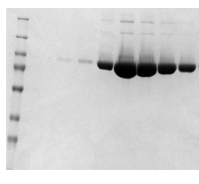

Sample directly from SEC run

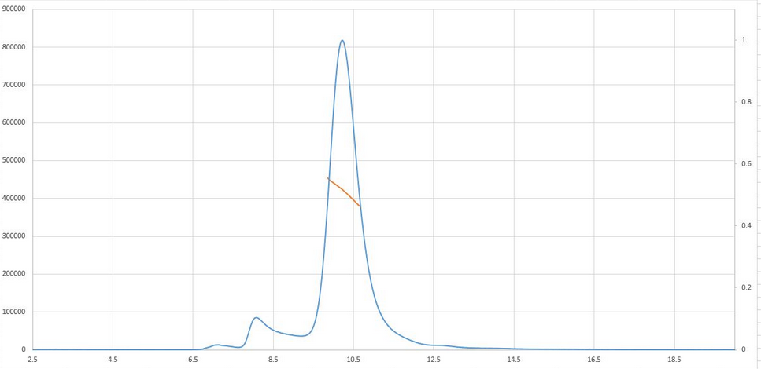

**Negative stain results:**

**To be filled by the cryo-EM facility:**

|  |  |
| --- | --- |
| **Concentration for NS experiment (full biological assembly in uM)** | 0.05 uM |
| **Adsorption time** | 60s |
| **Magnification** | 45x |
| **Defocus** | -3.0 |

**Grid table:**

|  |  |
| --- | --- |
| **Grid position** | **Status** |
| 20211125_BoxX_posX | screened |
|  |  |
|  |  |
|  |  |

**Representative micrograph:**

**Name:** 20211125_ BoxX_posX _NS_ Samplename_Surname _image1.jpg

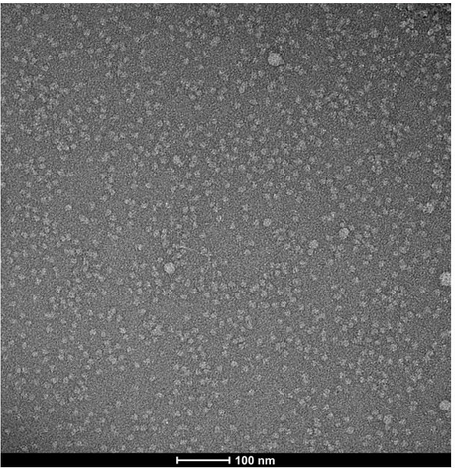

**Summary:**

Homogeneous sample, some aggregates, sample quality good for cryo-EM