Cryo-EM sample vitrification/screening datasheet
Please fill and save in format: YYYYMMDD_CryoEM _Samplename_Surname
Sample name | FluPol
Biological assembly | Influenza A virus RdRp
Group | Kouba
User name | Anatolij Filimoněnko
Tel. | 220 183 448
Email | anatolij.filimonenko@uochb.cas.cz
Date (YYYYMMDD) | 20210911
Negative stain experiment date(s) (YYYYMMDD) | 20211105
Molecular weight of full biological assembly (kDa) | 351 kDa
Oligomeric state (monomer, dimer) | heterotrimer
Concentration of full biological assembly (uM, minimum cca 1 uM) | 1,2 uM
Storage/freezing conditions (4°/-20°/-80°) | -80°/ LN flash freeze
1x sample buffer | 20 mM HEPES pH 7.5, 150 mM NaCl, 5 mM MgCl₂, 1 mM TCEP
Supplied sample buffer aliquot concertation (1x, 10x)  (minimum 1mL) | 10x
Additional information if available:
PDB code of known or homologous structure | 6RR7

Notes: Pure protein on SDS-PAGE
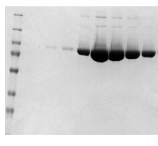
Sample directly from SEC run

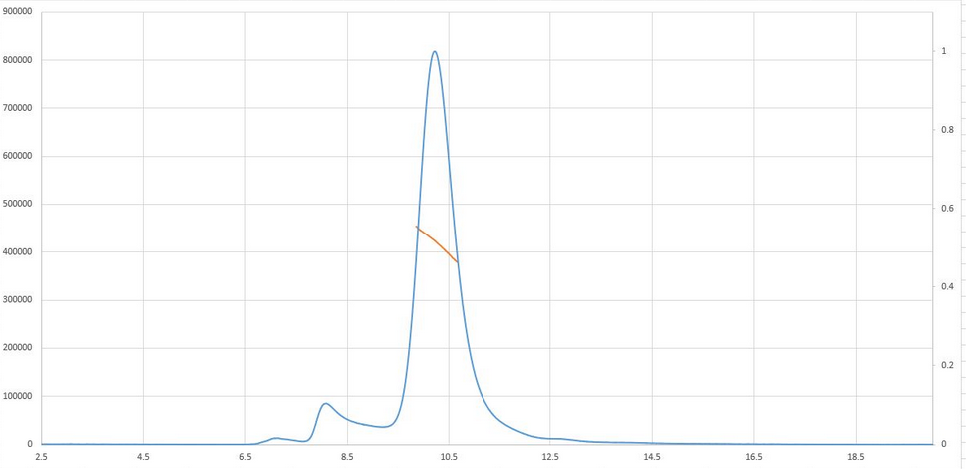
Negative stain image:
20211105
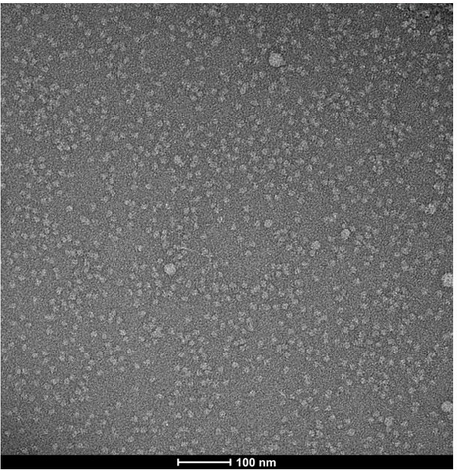

Cryo-EM sample vitrification/screening datasheet results:
To be filled by the cryo-EM facility

Vitrification:
Glow discharge | 2x20s 25mA 0.3mBar
Temperature/humidity | 4°/100%
Blotting force/time | -5/2s
Grid type | Q gold 300 mesh R1.3/1.2
Final sample conc. (full biological assembly in uM) | 0.8uM
Sample application | both sides 1.5+1.5ul

Grid table:
Grid position | Status
20211125_I1 | screened
20211125_I2 | stored
20211125_I3 | stored
20211125_I4 | stored

Vitrification:
Glow discharge | 2x20s 25mA 0.3mBar
Temperature/humidity | 4°/100%
Blotting force/time | -5/2s
Grid type | Q gold 300 mesh R2/1
Final sample conc. (full biological assembly in uM)
Sample application | both sides 1.5+1.5ul

Grid table:
Grid position | Status
20211125_II1 | stored
20211125_II2 | stored
20211125_II3 | stored
20211125_II4 | screened
Screening:
Sample name: YYYYMMDD_gridplace_CryoEM_Samplename_Surname

Atlas image:
Name: 20211125_I1_CryoEM_ Samplename_Surname _atlas.jpg
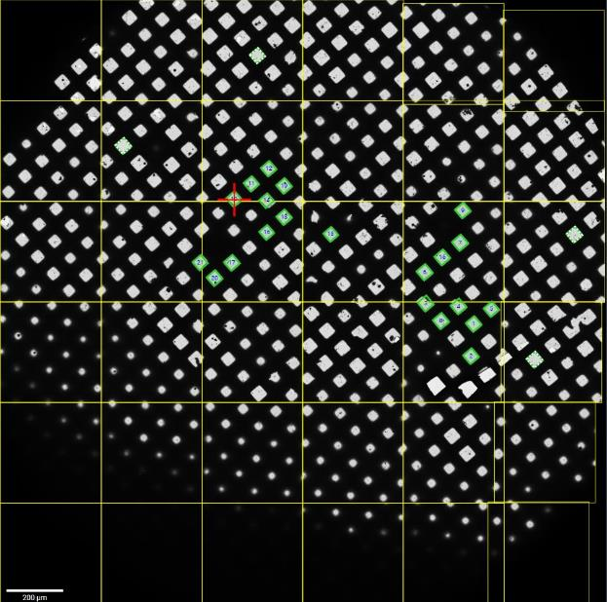

Representative images:

Square1
Name: 20211125_I1_CryoEM_ Samplename_Surname _sq1.jpg
Note: Small medium thick ice square
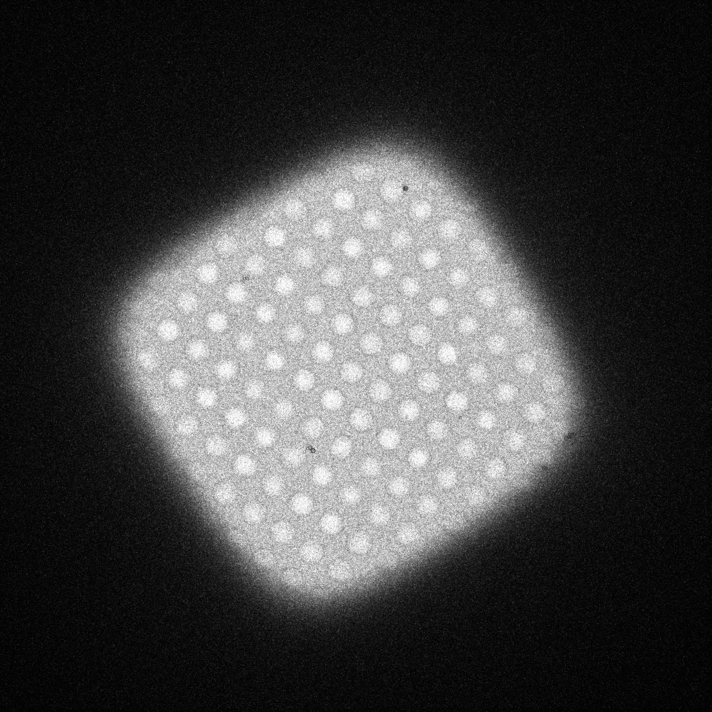
Hole1
Name: 20211125_I1_CryoEM_ Samplename_Surname _sq1_hole1.jpg
Note: Ice homogeneous within the hole
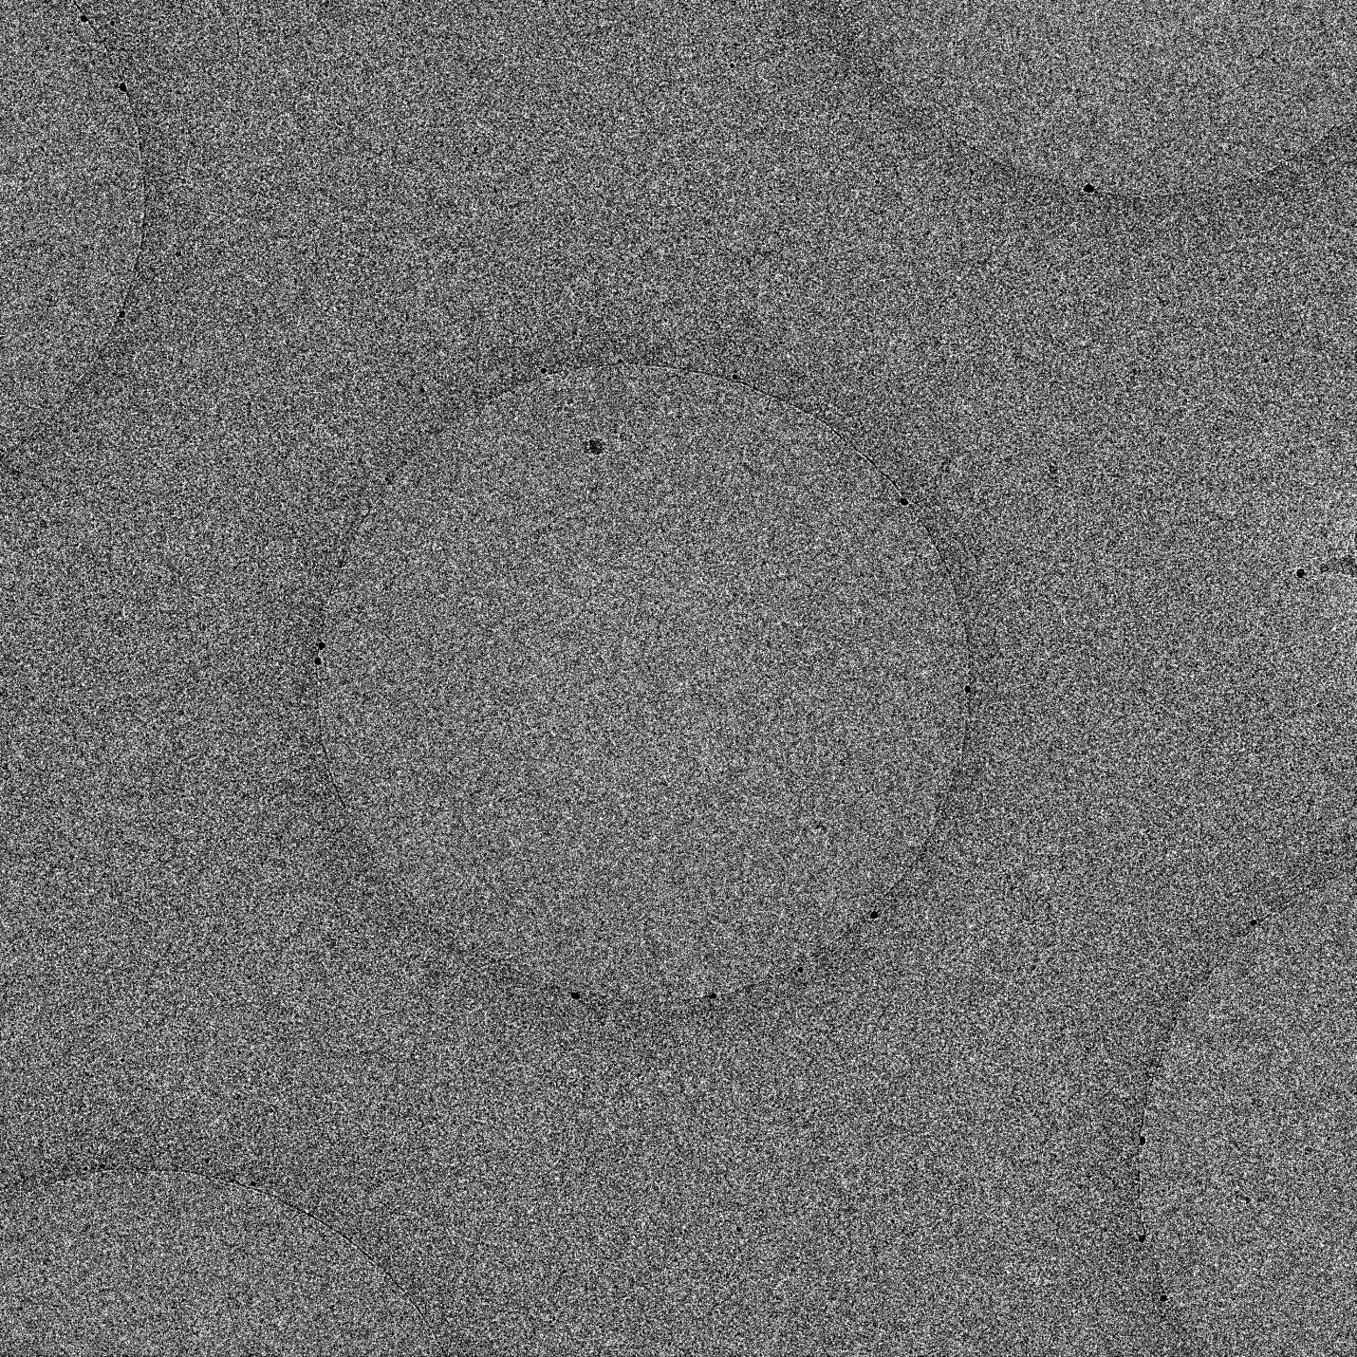

Pixel size (A/pixel) | 2.5
Defocus (um) | -3.0
Total exposure e/A² | 42
Operator | Kouba
Microscope/camera | FEI_Spectra/Gatan-Orius

Particles1:
Name:20211125_I1_ Samplename_Surname _sq1_hole1_par1.jpg
Note: Even distribution of particles throughout the hole, decent background
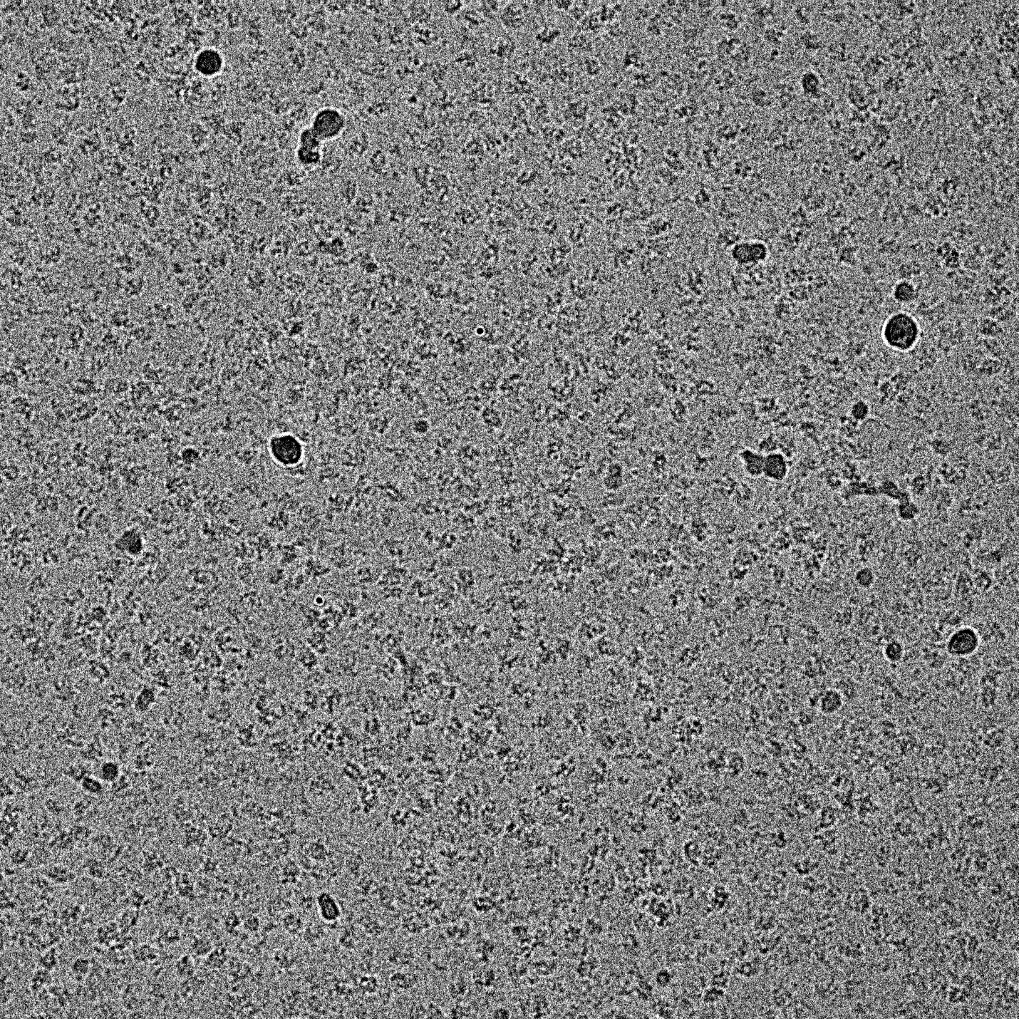

Square2
Name: 20211125_I1_CryoEM_ Samplename_Surname _sq2.jpg
Note: Big thin ice square
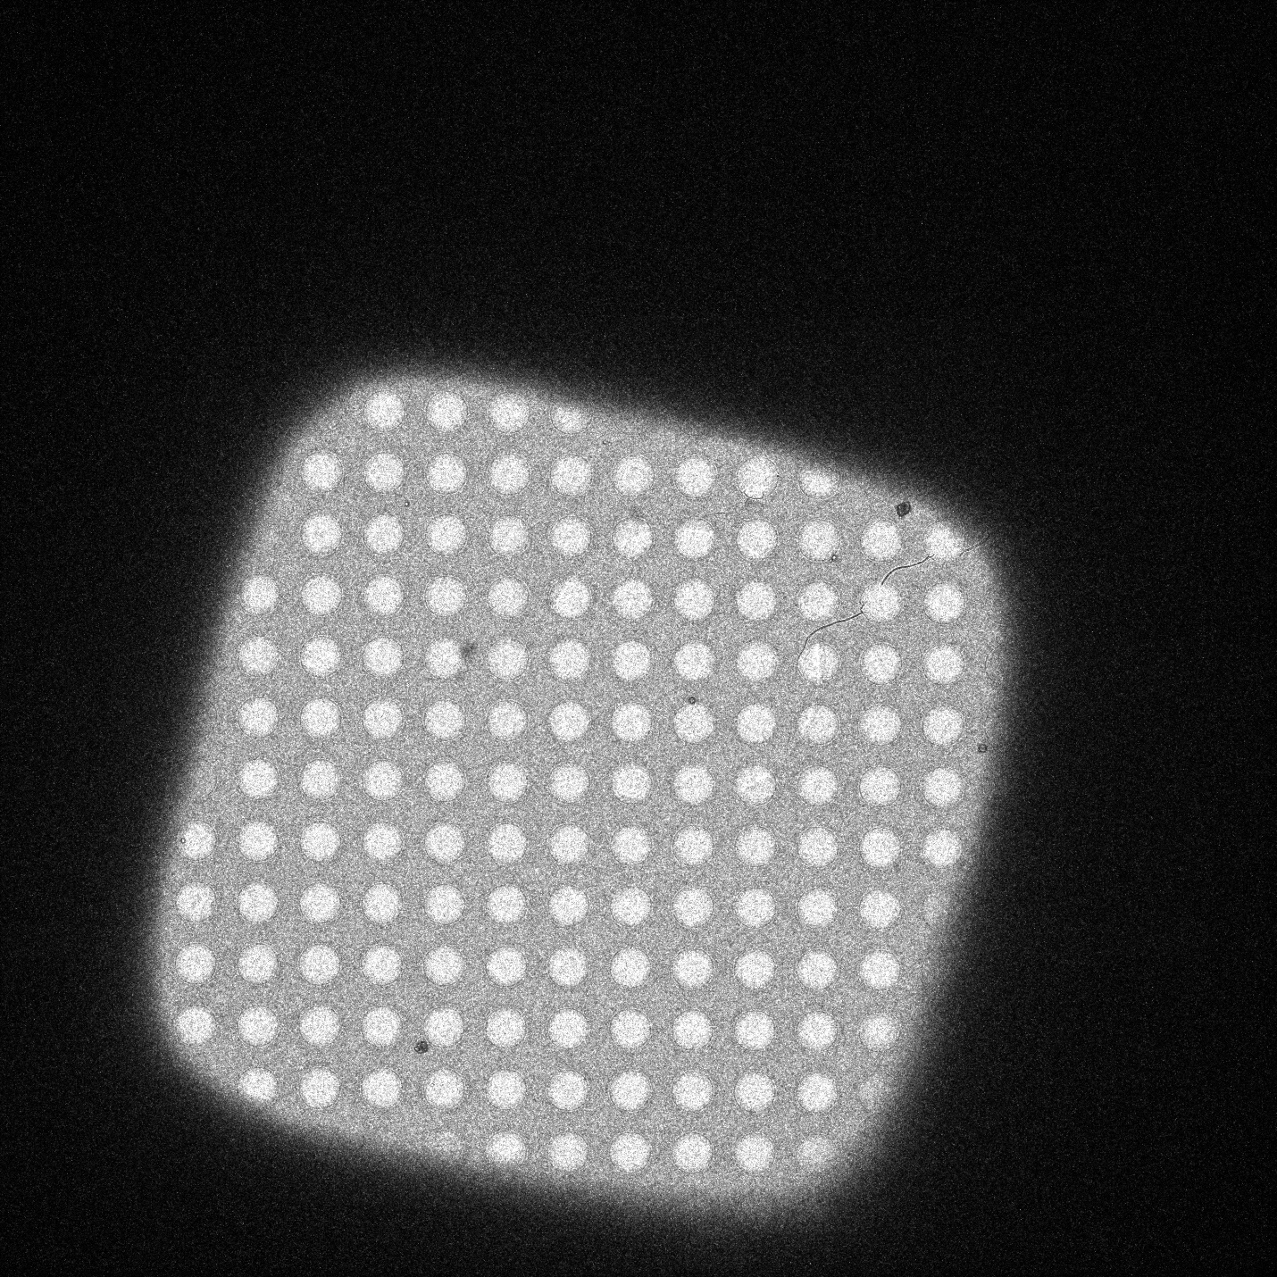
Hole2
Name: 20211125_I1_CryoEM_ Samplename_Surname _sq2_hole1.jpg
Note: Visible gradient of ice within the hole, very thin middle
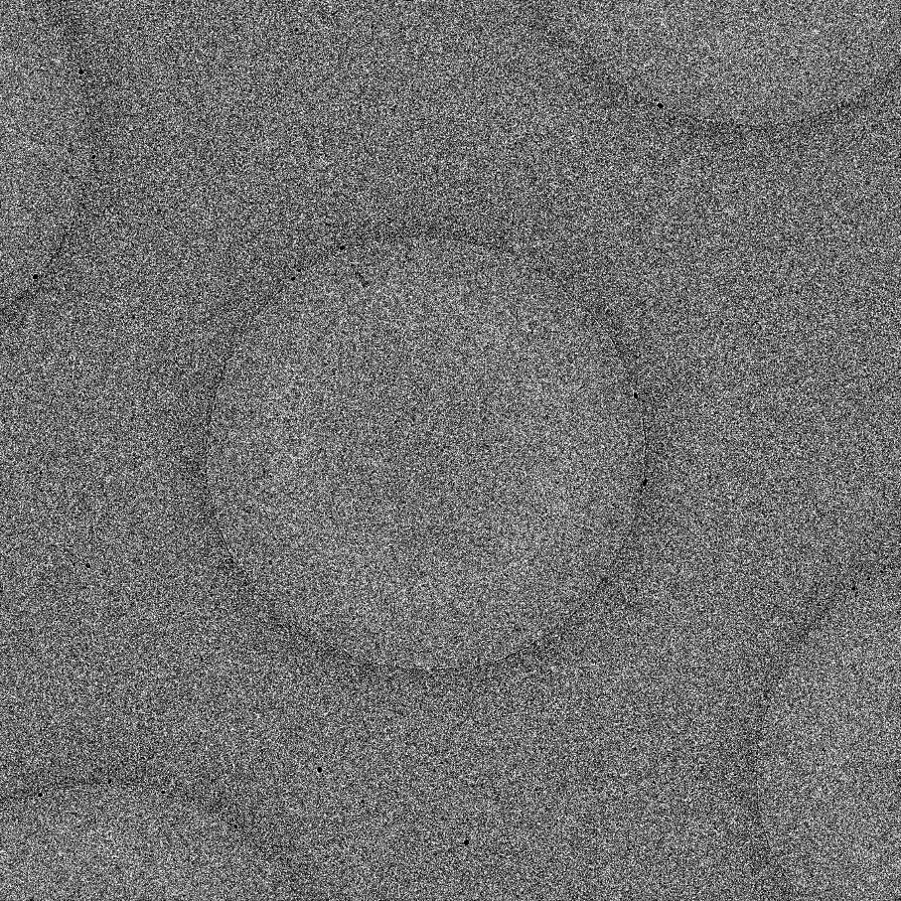

Pixel size (A/pixel) | 2.5
Defocus (um) | -3.0
Total exposure e/A² | 42
Operator | Kouba
Microscope/camera | FEI_Spectra/Gatan-Orius

Particles2:
Name: 20211125_I1_CryoEM_ Samplename_Surname _sq2_hole1_par1.jpg
Note: Particles only at edges, central part denatured
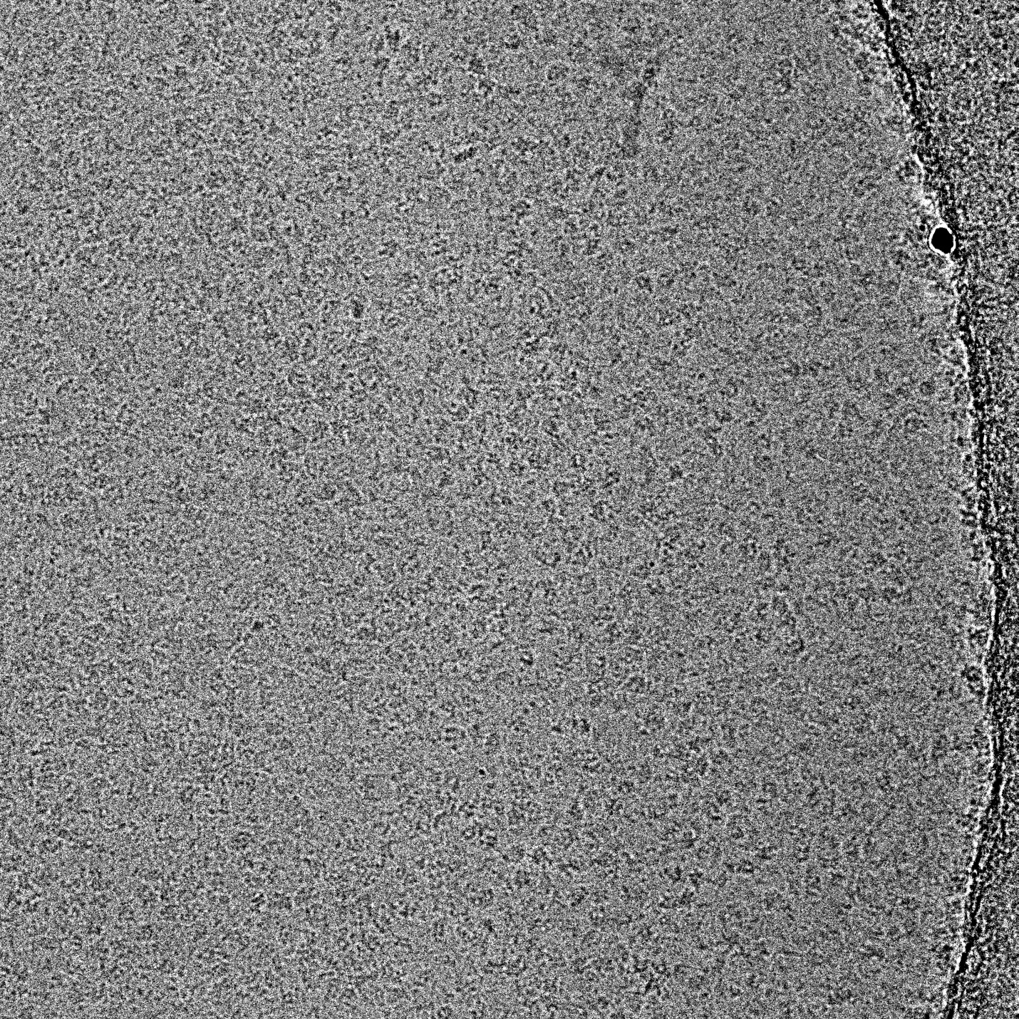

Summary:
Gradient of ice within the grid, large thin ice squares, medium size squares with medium thick ice, small square with very thick ice

No contaminations

Usable for high-res data collection

Use only smaller medium thick squares where particles are not denatured, or collect data on large thin squares but only around the very hole edges

